Mapping the Intrigacies of Ice and Fire: Character Networks in “Game of Thrones”

Santhosh Kumar Suresh Kumar  
santhoshkumarsures@lewisu.edu  
DATA-53000, Fall 2024

Data Visualization Lewis University

# Introduction

In the intricate world of George R.R. Martin's *A Song of Ice and Fire*, the complexities of character relationships and alliances form the backbone of the narrative. For my project, I leveraged Gephi, an advanced network analysis and visualization tool, to delve into the social dynamics of the *Game of Thrones* series. Using datasets provided by Sarmad Riaz [1] and sourced from the GitHub repository by MathBeveridge [2], I visualized the intricate web of connections between characters across the books. This visualization offers a unique perspective on the prominence, influence, and interrelationships of key characters. By representing the sprawling narrative as a network graph, we can uncover hidden patterns, pivotal characters, and the underlying structure of this epic saga. The insights gleaned from this analysis not only enhance our understanding of the series but also demonstrate the power of network visualization in exploring complex datasets.

# Data Description

The dataset used for this analysis consists of information on characters and their relationships in the *Game of Thrones* series. It includes a total of five datasets, each corresponding to one of the first five books in the series. These datasets provide a comprehensive view of the social dynamics and interactions between characters throughout the narrative. The data is structured with columns such as ID (a unique identifier for each character), Label (the character’s name), Source (ID of the character from which the connection originates), Target (ID of the character to which the connection points), Type (nature of the relationship or interaction), and Weight (strength or significance of the connection). By leveraging these datasets, we can visualize and analyze the intricate web of connections that form the backbone of this epic saga, uncovering hidden patterns and gaining deeper insights into the relationships and structures within the *Game of Thrones* universe.

Table I below lists the six key attributes that highlight the analysis of character relationships in *Game of Thrones*. These attributes provide a comprehensive overview of the social dynamics and interactions within the narrative, offering valuable insights into the connections and structures within this epic saga.

1. Data Attributes

| **Attribute** | **Type** | **Example Value** | **Description** |
| --- | --- | --- | --- |
| ID | Numeric | 1 | A unique identifier for each character. |
| Label | Categorical | Jon Snow | The character’s name. |
| Source | Numeric | 1 | ID of the character from which the connection originates. |
| Target | Numeric | 2 | ID of the character to which the connection points. |
| Type | Categorical | Undirected | The nature of the relationship or interaction. |
| Weight | Numeric | 2 | The strength or significance of the connection. |

# Methodology and results

To analyze the social dynamics of the *Game of Thrones* series, I employed Gephi, an advanced network analysis and visualization tool. First, I collected datasets corresponding to the first five books, which included nodes (characters) and edges (relationships). I imported these datasets into Gephi, where I cleaned and preprocessed the data to ensure accuracy and consistency. Each character and their interactions were represented as nodes and edges, respectively. I utilized Gephi's network visualization capabilities to create an initial graph layout. Next, I applied various network analysis metrics such as degree centrality, betweenness centrality, and modularity to identify key characters, influential relationships, and community structures. Finally, I refined the visualizations to highlight significant patterns and insights, providing a comprehensive view of the intricate web of character relationships within the Game of Thrones saga.

In Fig.1, The visualization for Book 1 of *A Game of Thrones* employs the ForceAtlas 2 layout, showcasing the relationships between characters in an intricate network graph. Nodes represent characters, with their sizes indicating the centrality and importance of each within the narrative. Edges signify the relationships or interactions between characters, varying in thickness to reflect the strength of these connections. The colors of nodes and edges distinguish different factions or groups, visually mapping out the social and political affiliations. The layout effectively clusters characters into communities. The modularity analysis, using Vincent D. Blondel's algorithm, identifies these clusters, while statistical inference, based on Lizhi Zhang and Tiago P. Peixoto's work, enhances understanding of community structures. Prominent figures like Eddard Stark, Jon Snow, and Daenerys Targaryen stand out, offering valuable insights into the social dynamics of the saga.

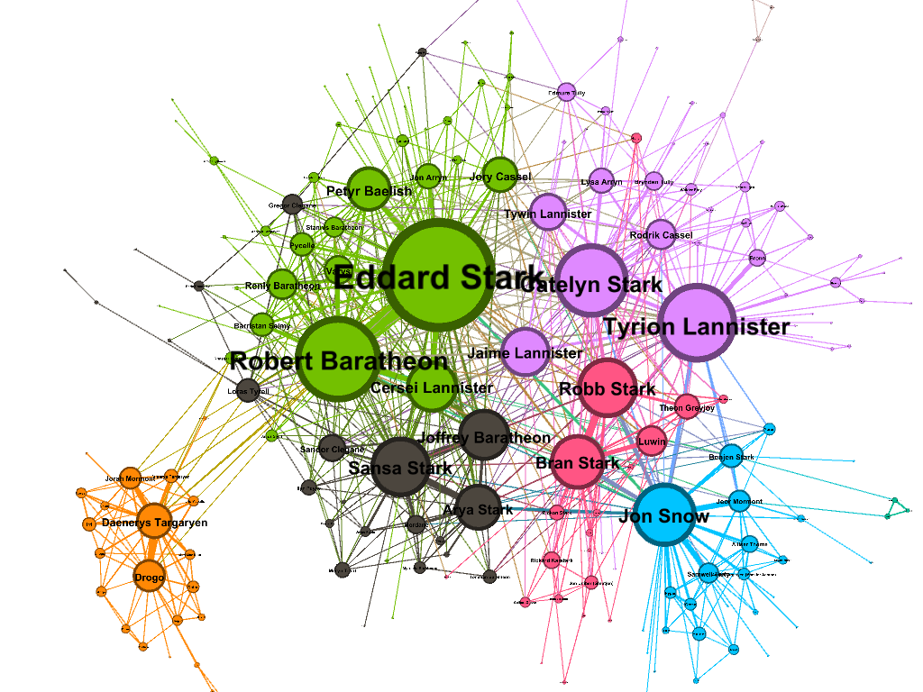Fig. 1 Network Graph of Character Relationships in Book 1 of *A Game of Thrones* Using ForceAtlas 2 Layout

In Fig. 2, The visualization for Book 1 of *A Game of Thrones* employs the Noverlap layout to ensure nodes do not overlap, providing a clear and organized representation of character relationships. In this network graph, nodes represent characters, sized proportionally to their centrality within the narrative. Edges indicate the relationships or interactions between characters, with varying thickness reflecting the strength of these connections. Different colors of nodes and edges distinguish various factions or groups, visually mapping out the social and political affiliations within the story. The layout effectively clusters characters into communities, highlighting key figures like Eddard Stark, Jon Snow, and Daenerys Targaryen. This graph is enhanced by modularity analysis using Vincent D. Blondel's algorithm to identify clusters, and statistical inference based on Lizhi Zhang and Tiago P. Peixoto's work to understand community structures. This detailed visualization uncovers the intricate social dynamics of the saga.

.

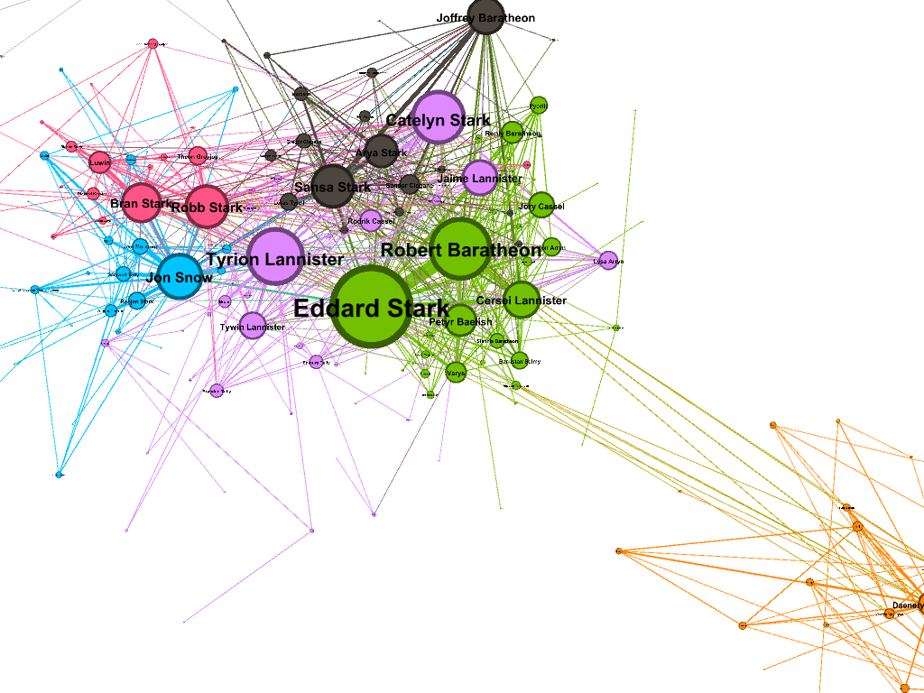

Fig. 2 Network Graph of Character Relationships in Book 1 of A Game of Thrones Using Noverlap Layout

In Fig. 3, This network graph uses the Yifan Hu layout, which is well-suited for visualizing complex networks. In this graph, nodes represent characters, with the size of each node indicating the character's centrality within the network. Edges denote relationships or interactions between characters, with varying thickness reflecting the strength of these connections. The nodes are color-coded to signify different groups or factions, allowing for a clear differentiation of social and political affiliations. Prominent characters like Eddard Stark, Robert Baratheon, Tyrion Lannister, Catelyn Stark, and Jon Snow are central, indicated by larger nodes. The modularity analysis using Vincent D. Blondel's algorithm identifies clusters, while statistical inference based on Lizhi Zhang and Tiago P. Peixoto's work enhances the understanding of community structures. This layout effectively reveals the intricate social dynamics and key relationships in the Game of Thrones saga.

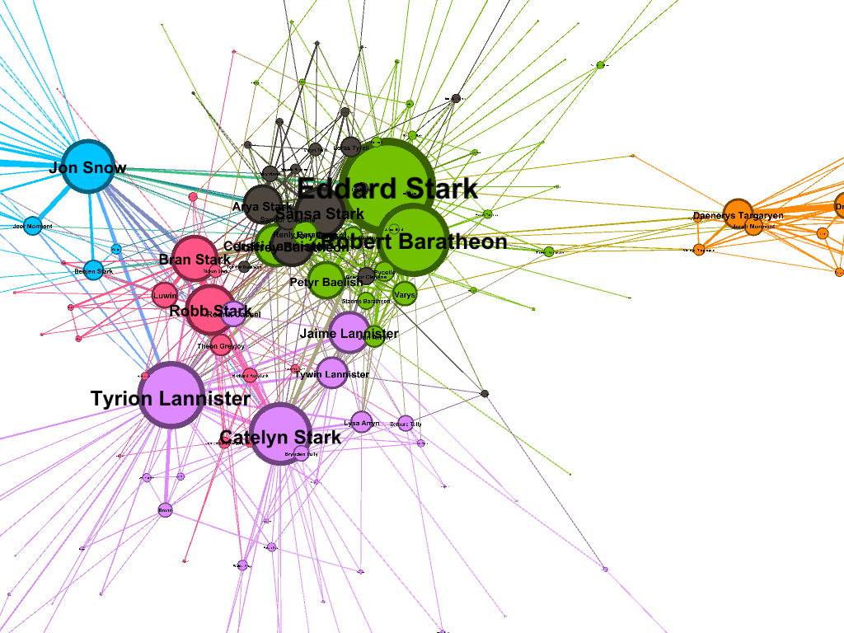

Fig.3 Network Graph of Character Relationships in Book 1 of A Game of Thrones Using Yifan Hu Layout

In Fig. 4, The visualization for Book 2 of *A Game of Thrones*, "A Clash of Kings," uses the Force Atlas layout to depict the complex relationships between characters. In this graph, nodes represent characters, sized based on their centrality, indicating their influence within the narrative. Edges denote relationships, with varying thickness to reflect the strength of these connections, and colors differentiate factions or groups, mapping out social and political affiliations. The modularity analysis, using Vincent D. Blondel's algorithm, identifies nine distinct communities within the network, providing insights into social structures and alliances. Additionally, the eigenvector centrality report, interpreted with 100 iterations, underscores the prominence of key characters such as Tyrion Lannister, Robb Stark, and Stannis Baratheon. Enhanced by statistical inference based on Lizhi Zhang and Tiago P. Peixoto's work, this visualization offers a detailed view of the evolving dynamics in the Game of Thrones saga, highlighting critical characters and their intricate relationships.

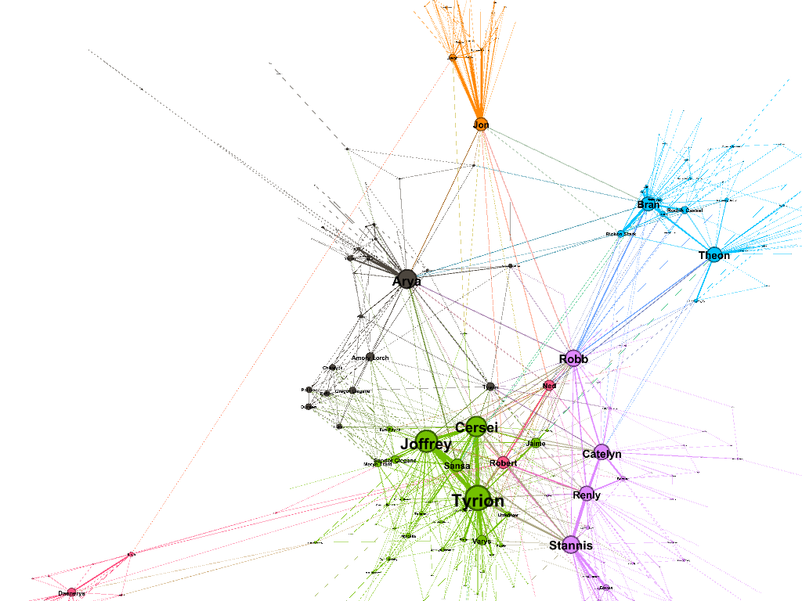

Fig. 4 Network Graph of Character Relationships in Book 2 of A Game of Thrones Using Force Atlas Layout

In Fig.5, The visualization for Book 2 of *A Game of Thrones*, "A Clash of Kings," uses the Fruchterman-Reingold layout to depict the complex relationships between characters. Nodes represent characters, sized based on their centrality, indicating their influence within the narrative. Edges denote relationships, with varying thickness to reflect the strength of these connections, and colors differentiate factions or groups, mapping out social and political affiliations. The modularity analysis, using Vincent D. Blondel's algorithm, identifies nine distinct communities within the network, providing insights into social structures and alliances. Additionally, the eigenvector centrality report, interpreted with 100 iterations, underscores the prominence of key characters such as Tyrion Lannister, Robb Stark, and Stannis Baratheon. Enhanced by statistical inference based on Lizhi Zhang and Tiago P. Peixoto's work, this visualization offers a detailed view of the evolving dynamics in the Game of Thrones saga, highlighting critical characters and their intricate relationships.

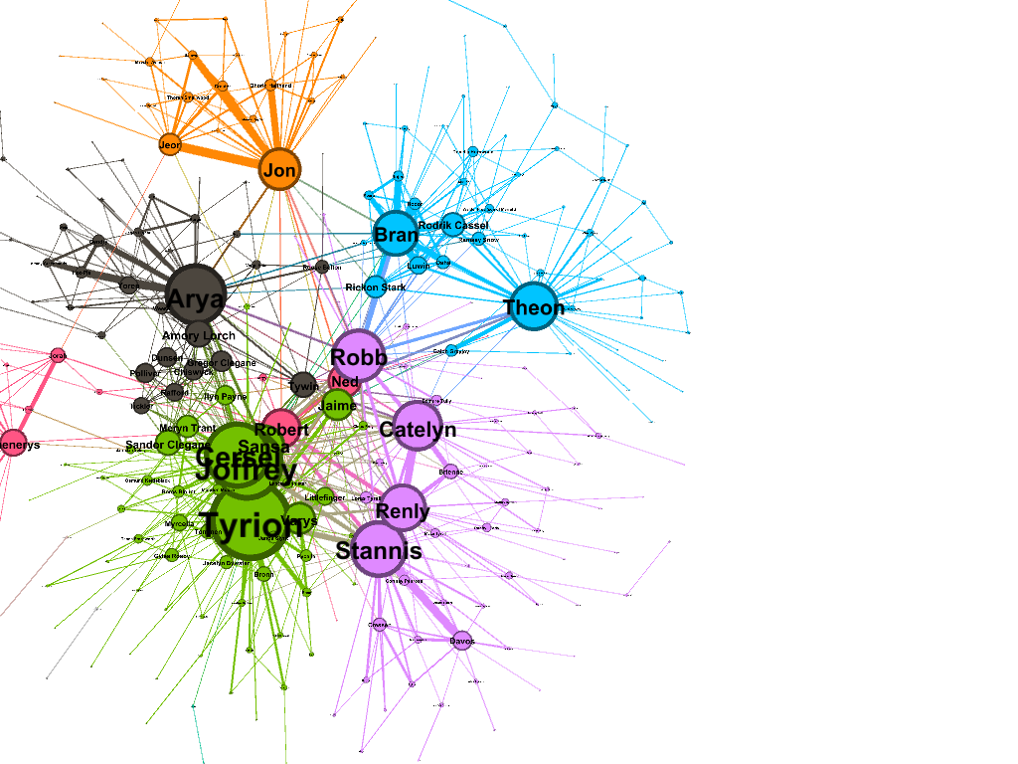

Fig.5 Network Graph of Character Relationships in Book 2 of A Game of Thrones Using Fruchterman-Reingold Layout

In Fig.6, The visualization for Book 2 of *A Game of Thrones*, "A Clash of Kings," uses the Yifan Hu proportional layout to depict the intricate relationships between characters. Nodes represent characters, sized according to their centrality, indicating their influence within the narrative. Edges denote relationships, with varying thickness reflecting the strength of these connections, and colors differentiate factions or groups, mapping out social and political affiliations. The modularity analysis, using Vincent D. Blondel's algorithm, identifies nine distinct communities within the network, providing insights into social structures and alliances. Additionally, the eigenvector centrality report, interpreted with 100 iterations, underscores the prominence of key characters such as Tyrion Lannister, Robb Stark, and Stannis Baratheon. Enhanced by statistical inference based on Lizhi Zhang and Tiago P. Peixoto's work, this visualization offers a detailed view of the evolving dynamics in the Game of Thrones saga, highlighting critical characters and their intricate relationships.

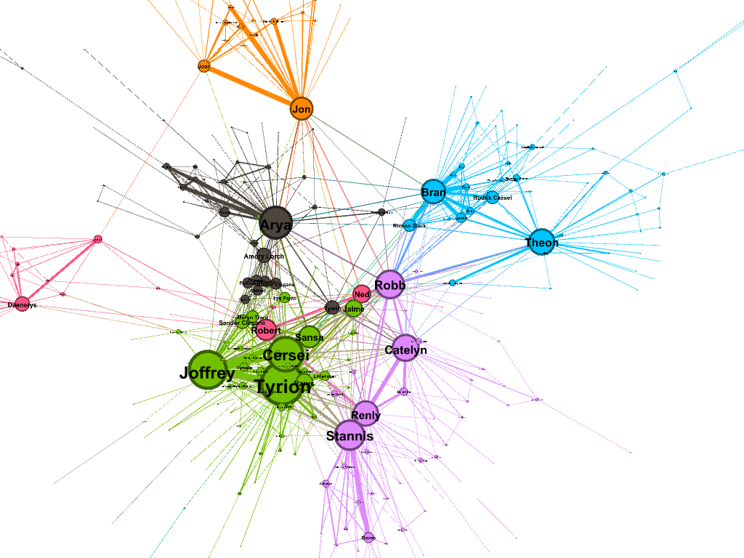

Fig.6 Network Graph of Character Relationships in Book 2 of A Game of Thrones Using Yifan Hu Proportional Layout

In Fig.7, The visualization for Book 3 of *A Game of Thrones*, "A Storm of Swords," uses the ForceAtlas layout to depict the complex relationships between characters. Nodes represent characters, sized according to their centrality, indicating their influence within the narrative. Edges denote relationships, with varying thickness reflecting the strength of these connections, and colors differentiate factions or groups, mapping out social and political affiliations. The modularity analysis, using Vincent D. Blondel's algorithm, identifies ten distinct communities within the network, providing insights into social structures and alliances. Additionally, the eigenvector centrality report, interpreted with 100 iterations, underscores the prominence of key characters such as Jon Snow, Arya Stark, Tyrion Lannister, and Cersei Lannister. Enhanced by statistical inference based on Lizhi Zhang and Tiago P. Peixoto's work, this visualization offers a detailed view of the evolving dynamics in the Game of Thrones saga, highlighting critical characters and their intricate relationships.

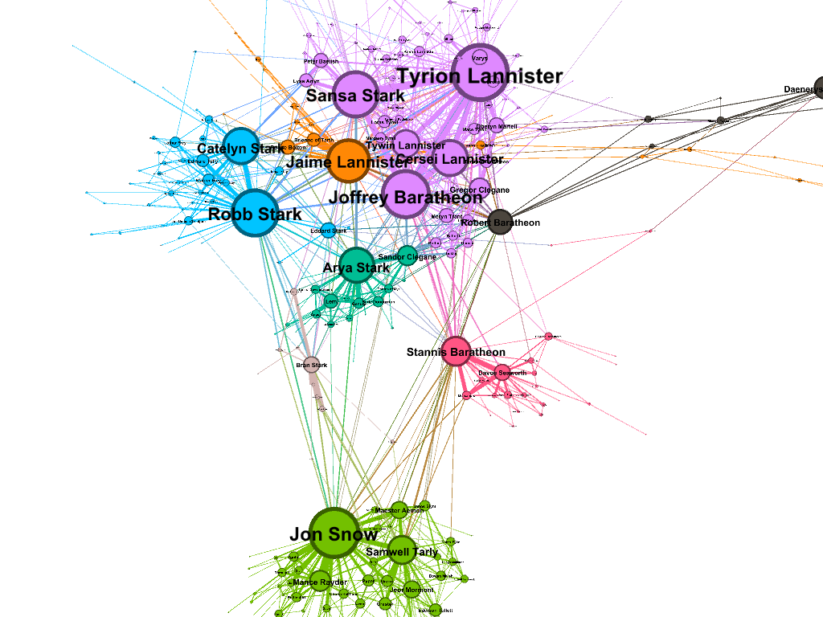

Fig.7 Network Graph of Character Relationships in Book 3 of A Game of Thrones Using ForceAtlas Layout

In Fig.8, The visualization for Book 3 of *A Game of Thrones*, "A Storm of Swords," utilizes the Fruchterman-Reingold layout to depict the complex relationships between characters. Nodes represent characters, sized according to their centrality, indicating their importance within the narrative. Edges denote relationships, with varying thickness reflecting the strength of these connections. Different colors are used to group characters into clusters, likely representing various families or factions within the series. The modularity analysis, using Vincent D. Blondel's algorithm, identifies ten distinct communities, providing insights into social structures and alliances. The eigenvector centrality report highlights influential characters like Jon Snow, Arya Stark, Tyrion Lannister, and Cersei Lannister. Enhanced by statistical inference based on Lizhi Zhang and Tiago P. Peixoto's work, this visualization offers a detailed view of the evolving dynamics in the Game of Thrones saga, revealing critical characters and their intricate relationships.

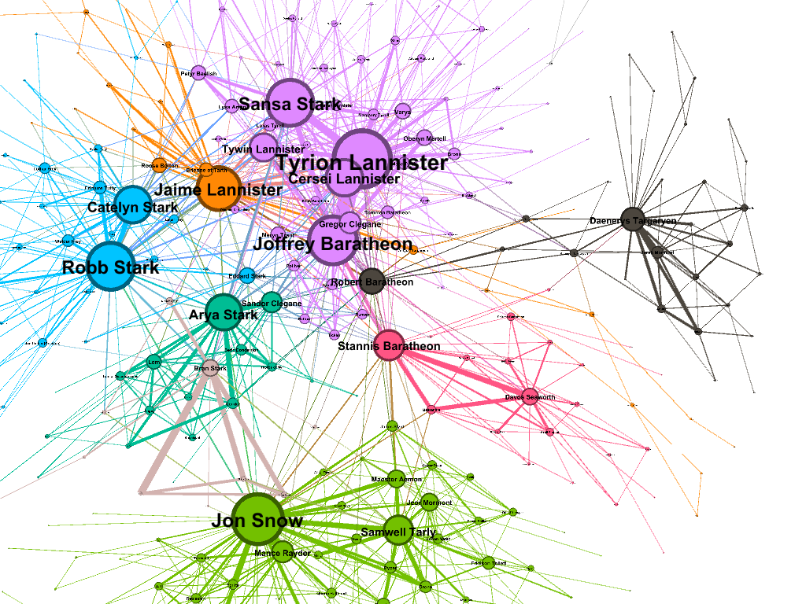

Fig.8 Network Graph of Character Relationships in Book 3 of A Game of Thrones Using Fruchterman-Reingold Layout

In Fig.9, The visualization for Book 3 of *A Game of Thrones*, "A Storm of Swords," uses the OpenOrd layout to depict the intricate relationships between characters. Nodes represent characters, sized according to their centrality, indicating their influence within the narrative. Edges denote relationships, with varying thickness reflecting the strength of these connections. Different colors are used to group characters into clusters, likely representing various factions or families within the series. The modularity analysis, using Vincent D. Blondel's algorithm, identifies ten distinct communities, providing insights into social structures and alliances. The eigenvector centrality report highlights influential characters like Jon Snow, Arya Stark, Tyrion Lannister, and Cersei Lannister. Enhanced by statistical inference based on Lizhi Zhang and Tiago P. Peixoto's work, this visualization offers a detailed view of the evolving dynamics in the Game of Thrones saga, revealing critical characters and their intricate relationships.

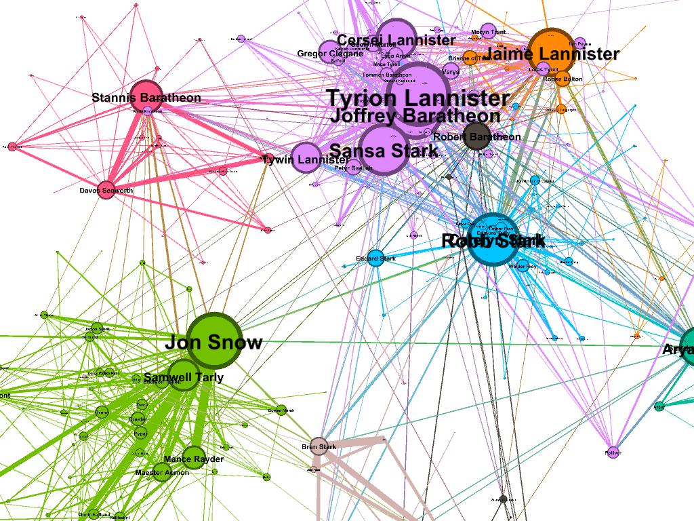

Fig.9 Network Graph of Character Relationships in Book 3 of A Game of Thrones Using OpenOrd Layout

In Fig.10, The visualization for Book 4 of *A Game of Thrones*, "A Feast for Crows," employs the ForceAtlas 2 layout to depict the intricate web of relationships between characters. Nodes represent characters, sized based on their centrality, indicating their influence within the narrative. Edges denote relationships, with varying thickness reflecting the strength of these connections. The colors of the nodes group characters into different factions or families, highlighting their social and political affiliations. The modularity analysis, using Vincent D. Blondel's algorithm, identifies thirteen distinct communities, providing insights into social structures and alliances. The graph distance report shows a diameter of 10, a radius of 5, and an average path length of 3.98, indicating the complexity of the network. Key characters such as Jaime Lannister, Cersei Lannister, and Brienne of Tarth stand out prominently. Enhanced by statistical inference based on Lizhi Zhang and Tiago P. Peixoto's work, this visualization offers a detailed view of the evolving dynamics in the Game of Thrones saga, revealing critical characters and their intricate relationships.

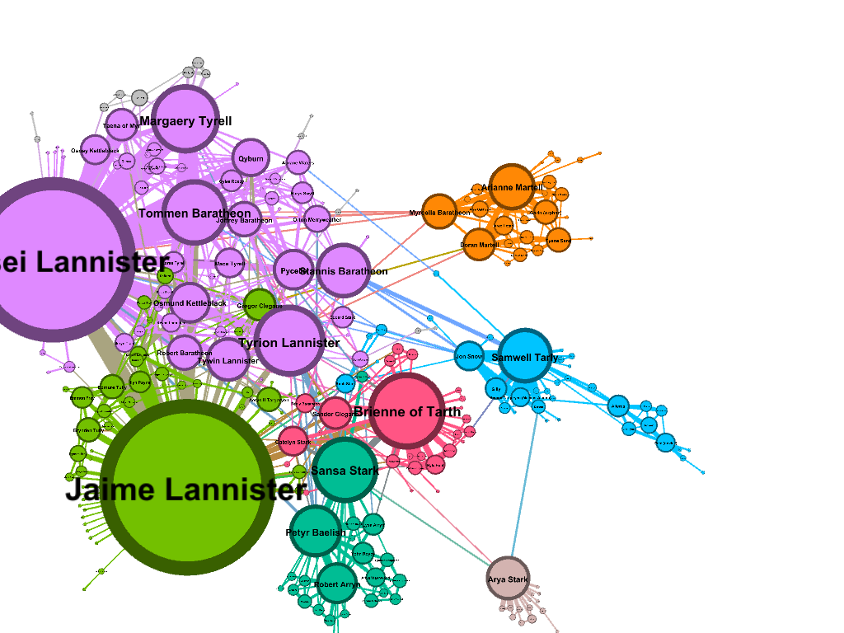

Fig.10 Network Graph of Character Relationships in Book 4 of A Game of Thrones Using ForceAtlas 2 Layout

InFig.11 The visualization for Book 4 of *A Game of Thrones*, "A Feast for Crows," uses the Fruchterman-Reingold layout to illustrate the complex relationships between characters. Nodes represent characters, with their sizes indicating centrality, highlighting the most influential figures. Edges represent relationships, varying in thickness to show the strength of connections. Different colors group characters into factions or families, mapping out social and political affiliations. The modularity analysis, using Vincent D. Blondel's algorithm, identifies thirteen distinct communities within the network, offering insights into social structures and alliances. The graph distance report shows a diameter of 10, a radius of 5, and an average path length of 3.98, indicating the network's complexity. Influential characters like Jaime Lannister, Cersei Lannister, and Brienne of Tarth stand out prominently. Enhanced by statistical inference based on Lizhi Zhang and Tiago P. Peixoto's work, this visualization provides a detailed view of the evolving dynamics in the Game of Thrones saga, revealing critical characters and their intricate relationships.

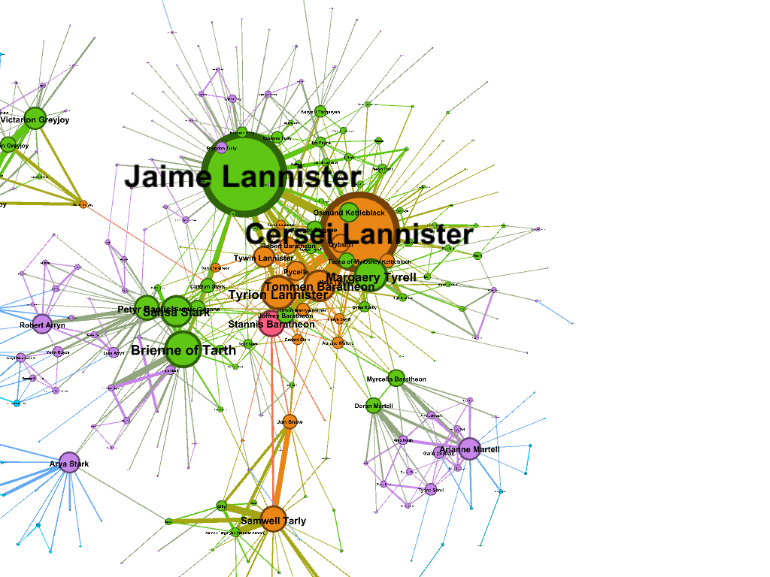

Fig.11 Network Graph of Character Relationships in Book 4 of A Game of Thrones Using Fruchterman-Reingold Layout

In Fig.12, The visualization for Book 4 of A Game of Thrones, "A Feast for Crows," uses a random layout to depict the complex relationships between characters. Nodes represent characters, sized according to their centrality, indicating their influence within the narrative. Edges denote relationships, with varying thickness reflecting the strength of these connections. Different colors group characters into factions or families, mapping out social and political affiliations. The modularity analysis, using Vincent D. Blondel's algorithm, identifies thirteen distinct communities within the network, offering insights into social structures and alliances. The graph distance report shows a diameter of 10, a radius of 5, and an average path length of 3.98, indicating the network's complexity. Influential characters like Jaime Lannister, Cersei Lannister, and Brienne of Tarth stand out prominently. Enhanced by statistical inference based on Lizhi Zhang and Tiago P. Peixoto's work, this visualization provides a detailed view of the evolving dynamics in the Game of Thrones saga, revealing critical characters and their intricate relationships.

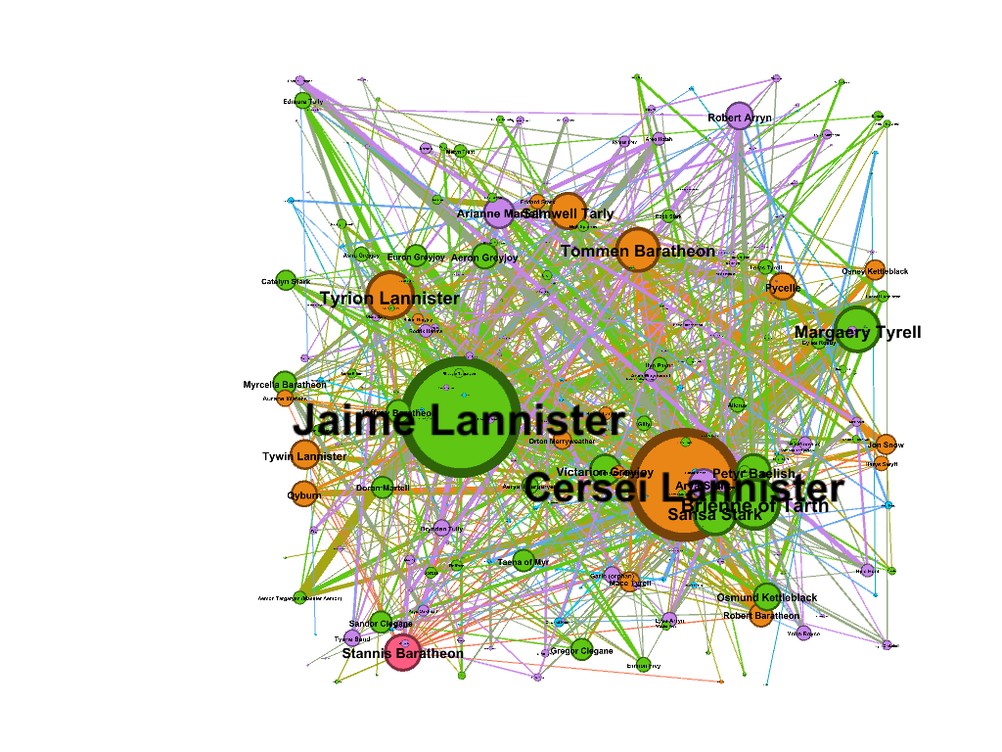

Fig.12 Network Graph of Character Relationships in Book 4 of A Game of Thrones Using Random Layout

In Fig.13, The visualization for Book 5 of A Game of Thrones, "A Dance with Dragons," employs the Force Atlas 2 layout to depict the complex relationships between characters. Nodes represent characters, sized according to their centrality, indicating their influence within the narrative. Edges denote relationships, with varying thickness reflecting the strength of these connections, and colors differentiate factions or groups, mapping out social and political affiliations. The modularity analysis, using Vincent D. Blondel's algorithm, identifies ten distinct communities, while the statistical inference report by Lizhi Zhang and Tiago P. Peixoto outlines seven communities, highlighting the intricate modular structures within the network. Notable characters such as Jon Snow, Daenerys Targaryen, Tyrion Lannister, and Cersei Lannister stand out prominently. The visualization also features a graph distance report, with a diameter of 10, a radius of 5, and an average path length of 3.98, showcasing the complexity of the network. This visualization, enhanced by Bayesian stochastic blockmodeling insights, offers a comprehensive view of the evolving dynamics in the Game of Thrones saga.

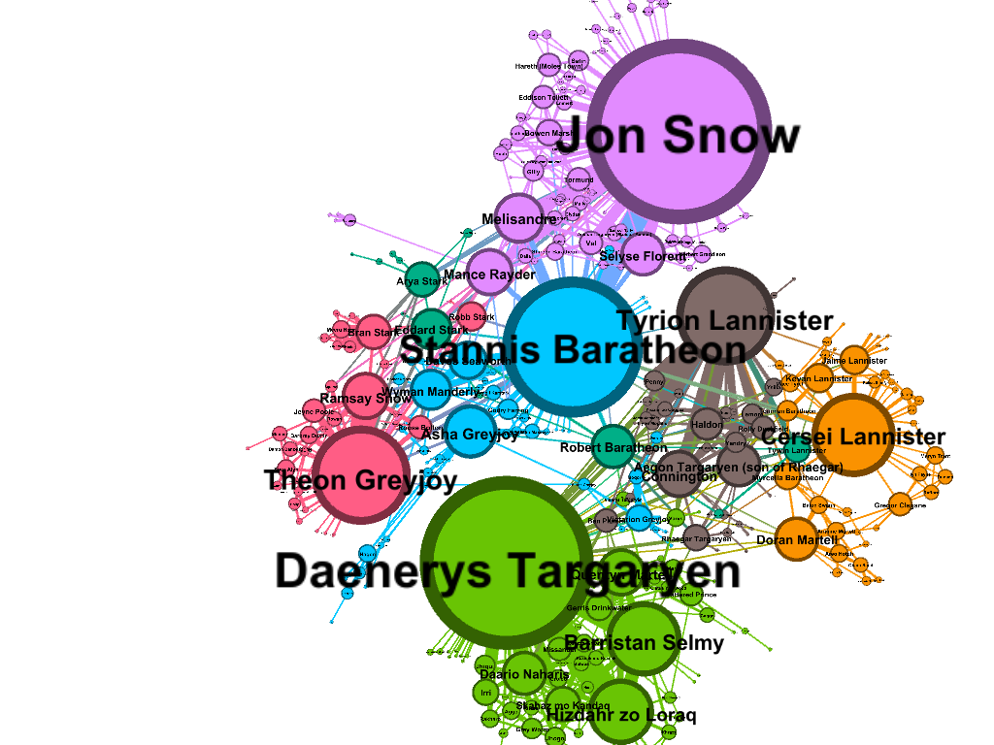

Fig.13 Network Graph of Character Relationships in Book 5 of A Game of Thrones Using Force Atlas 2 Layout

In Fig.14, The visualization for Book 5 of A Game of Thrones, "A Dance with Dragons," employs the Fruchterman-Reingold layout to depict the complex relationships between characters. Nodes represent characters, sized according to their centrality, indicating their influence within the narrative. Edges denote relationships, with varying thickness reflecting the strength of these connections. Colors differentiate factions or groups, mapping out social and political affiliations. The modularity analysis, using Vincent D. Blondel's algorithm, identifies ten distinct communities, while the statistical inference report by Lizhi Zhang and Tiago P. Peixoto outlines seven communities, highlighting the intricate modular structures within the network. Notable characters such as Jon Snow, Daenerys Targaryen, Tyrion Lannister, and Cersei Lannister stand out prominently. Enhanced by insights from Bayesian stochastic blockmodeling, this visualization provides a comprehensive view of the evolving dynamics in the Game of Thrones saga, revealing critical characters and their intricate relationships.

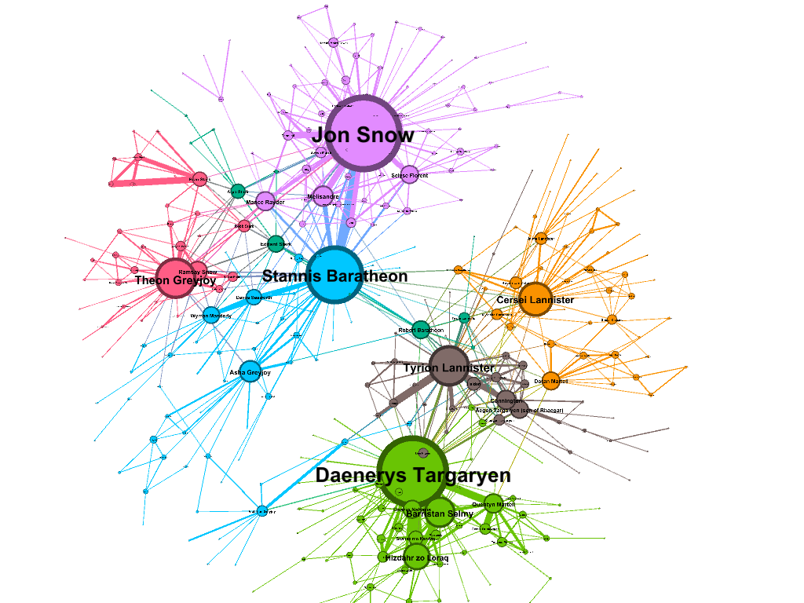

Fig.14 Network Graph of Character Relationships in Book 5 of A Game of Thrones Using Fruchterman-Reingold Layout

In Fig.15, The visualization for Book 5 of A Game of Thrones, "A Dance with Dragons," uses the Yifan Hu proportional layout to depict the complex relationships between characters. Nodes represent characters, sized according to their centrality, indicating their influence within the narrative. Edges denote relationships, with varying thickness reflecting the strength of these connections. Different colors group characters into factions or families, highlighting social and political affiliations. The modularity analysis, using Vincent D. Blondel's algorithm, identifies ten distinct communities, while the statistical inference report by Lizhi Zhang and Tiago P. Peixoto outlines seven communities, highlighting the intricate modular structures within the network. Notable characters such as Jon Snow, Daenerys Targaryen, Tyrion Lannister, and Cersei Lannister stand out prominently. Enhanced by insights from Bayesian stochastic blockmodeling, this visualization provides a detailed view of the evolving dynamics in the Game of Thrones saga, revealing critical characters and their intricate relationships.

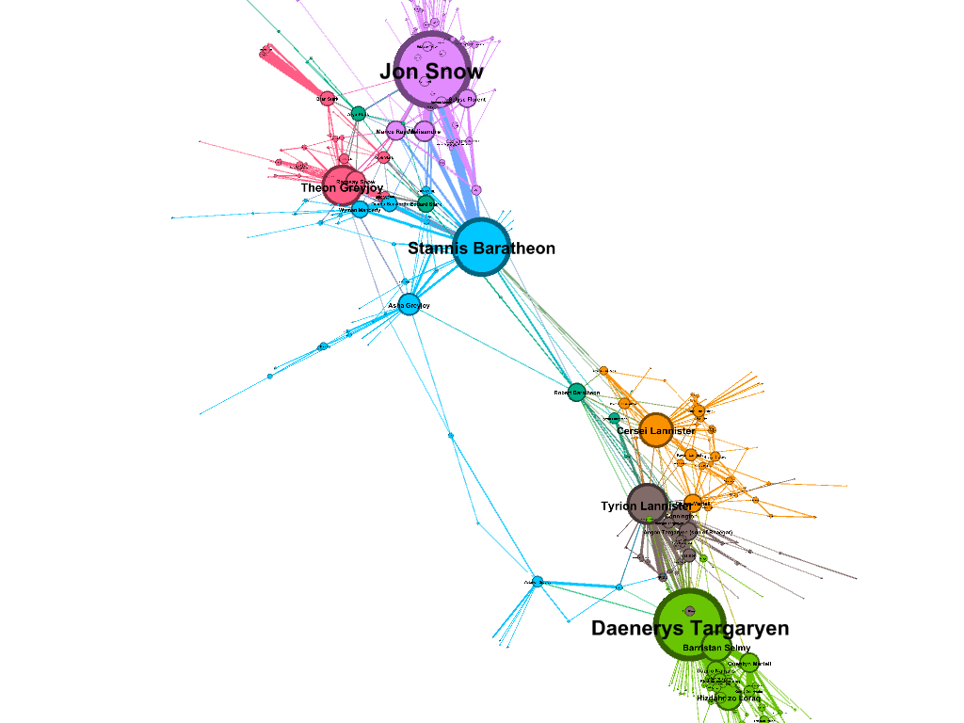

Fig.15 Network Graph of Character Relationships in Book 5 of A Game of Thrones Using Yifan Hu Proportional Layout

# Discussion

The analysis of character relationships in George R.R. Martin's A Song of Ice and Fire series, visualized through various network layouts in Gephi, provides a unique lens to understand the complexities and dynamics of this intricate narrative. By employing layouts such as ForceAtlas 2, Fruchterman-Reingold, Yifan Hu proportional, and OpenOrd, the visualizations reveal the centrality and influence of key characters, the strength of their relationships, and the modular structures within the network. The datasets spanning the first five books capture the evolving political affiliations and social interactions among characters, highlighting the prominence of figures like Jon Snow, Daenerys Targaryen, Tyrion Lannister, and Cersei Lannister. The use of modularity analysis, based on Vincent D. Blondel's algorithm, and statistical inference by Lizhi Zhang and Tiago P. Peixoto, further enriches the understanding of community structures and pivotal alliances within the series. These visualizations underscore the interconnectedness of the characters and the underlying power dynamics that drive the plot forward, offering a comprehensive view of the narrative's social fabric. Figures 1 through 15 illustrate these intricate relationships across various books and layouts.

The insights gleaned from the network analysis underscore the importance of central characters and their roles within the broader context of the series. The modularity and centrality metrics highlight how certain characters act as bridges between different communities, facilitating alliances or conflicts that are central to the plot. The visualization techniques employed not only elucidate the social hierarchies and affiliations but also uncover hidden patterns and potential narrative arcs that may not be immediately apparent from the text alone. By transforming the narrative into a network graph, we can appreciate the complexity and depth of Martin's storytelling, gaining a deeper appreciation for the intricate web of relationships that define the *Game of Thrones* saga. This project exemplifies the power of network visualization in exploring and interpreting complex datasets, providing valuable insights that enhance our understanding of the series and its characters. The detailed visualizations and analyses serve as a testament to the richness of the narrative and the potential of data visualization in uncovering hidden dimensions of storytelling, as seen in Figures 1 through 15.

# Conclusions

In conclusion, the analysis and visualization of character relationships in George R.R. Martin's *A Song of Ice and Fire* series offer a compelling exploration of the intricate social dynamics that underpin the narrative. By using advanced network analysis techniques and visualization tools such as Gephi, we have effectively mapped out the complex web of interactions between key characters across the first five books. Applying various layout algorithms, including ForceAtlas 2, Fruchterman-Reingold, Yifan Hu proportional, and OpenOrd, has yielded unique insights into the centrality, influence, and modular structures of these characters. The modularity analysis and statistical inference highlighted the community structures and pivotal alliances within the series, revealing how characters like Jon Snow, Daenerys Targaryen, Tyrion Lannister, and Cersei Lannister navigate the complex political and social landscapes of Westeros. These visualizations underscore the interconnectedness and underlying power dynamics that drive the plot, enhancing our understanding of the series' intricate storytelling. By transforming the narrative into a network graph, we can appreciate the depth and complexity of Martin's world-building, uncovering hidden patterns and potential narrative arcs that enrich our engagement with the story. This project not only demonstrates the power of network visualization in exploring and interpreting complex datasets but also provides a valuable framework for analyzing other richly detailed fictional universes. The detailed visualizations and analyses serve as a testament to the richness of the *Game of Thrones* saga and the potential of data visualization to uncover hidden dimensions of storytelling.

##### References

[1] Sarmad Riaz, “A Network Analysis of Game of Thrones” [Online]

Available: <https://www.kaggle.com/datasets/sarmadriaz/a-network-analysis-of-game-of-thrones>

[2] MathBeveridge, “A Song of Ice and Fire Network” [Online]

Available: <https://github.com/mathbeveridge/asoiaf/tree/master?tab=readme-ov-file>